BANKING TRANSACTION
ANALYSIS PROJECT

Project Report

Technology: PySpark | Platform: Jupyter Notebook
Dataset: 50,000 Banking Transactions

1. Project Overview
This project focuses on Banking Transaction Analysis using PySpark to process and analyze large-scale banking data efficiently. It helps in identifying transaction patterns, calculating balances, and detecting unusual or suspicious activities. The analysis provides useful insights for better financial monitoring and decision-making.

Key highlights of this project:
- Processes 50,000 real-world banking transactions at scale using distributed computing.
- Detects suspicious/high-value transactions exceeding a defined threshold.
- Identifies most active customers and accounts with highest total balances.
- Generates visualizations for transaction type distribution and balance comparisons.

Project Title | Banking Transaction Analysis
Technology | PySpark (Apache Spark)
Platform | Jupyter Notebook / JupyterLab
Dataset Size | 50,000 Banking Transactions
Language | Python 3
Objective | Transaction pattern analysis, fraud detection & financial insights

2. Spark Session Setup
The first step in the project is to initialize a PySpark Spark Session, which is the entry point for all Spark functionality. The SparkSession is configured with the application name "Banking Transaction Analysis" and uses getOrCreate() to either create a new session or retrieve an existing one. The successful initialization is confirmed with a print statement.

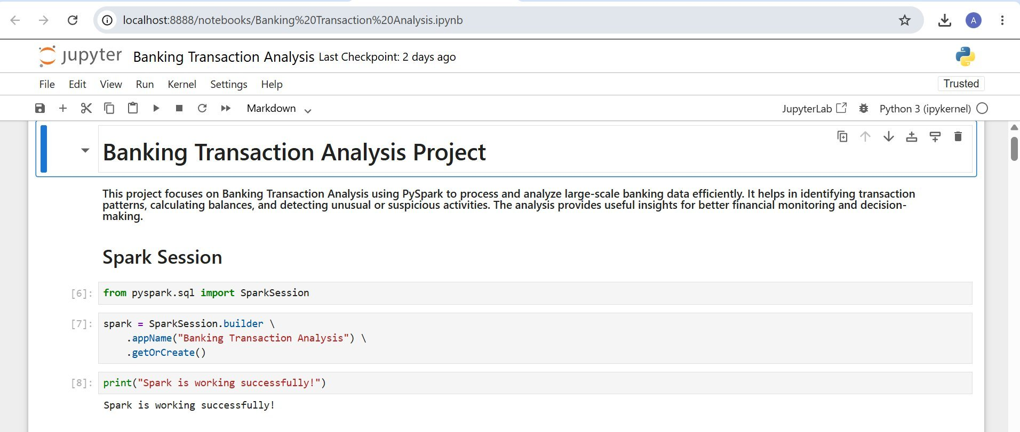
Figure 1: Spark Session initialization confirming PySpark is working successfully

3. Display Dataset
The dataset is loaded into a PySpark DataFrame and displayed using df.show(). The dataset contains 16 columns including TransactionID, AccountID, TransactionAmount, TransactionDate, TransactionType, Location, DeviceID, IP Address, MerchantID, Channel, CustomerAge, CustomerOccupation, TransactionDuration, LoginAttempts, and AccountBalance. Each row represents a unique banking transaction with metadata about the customer and transaction method.

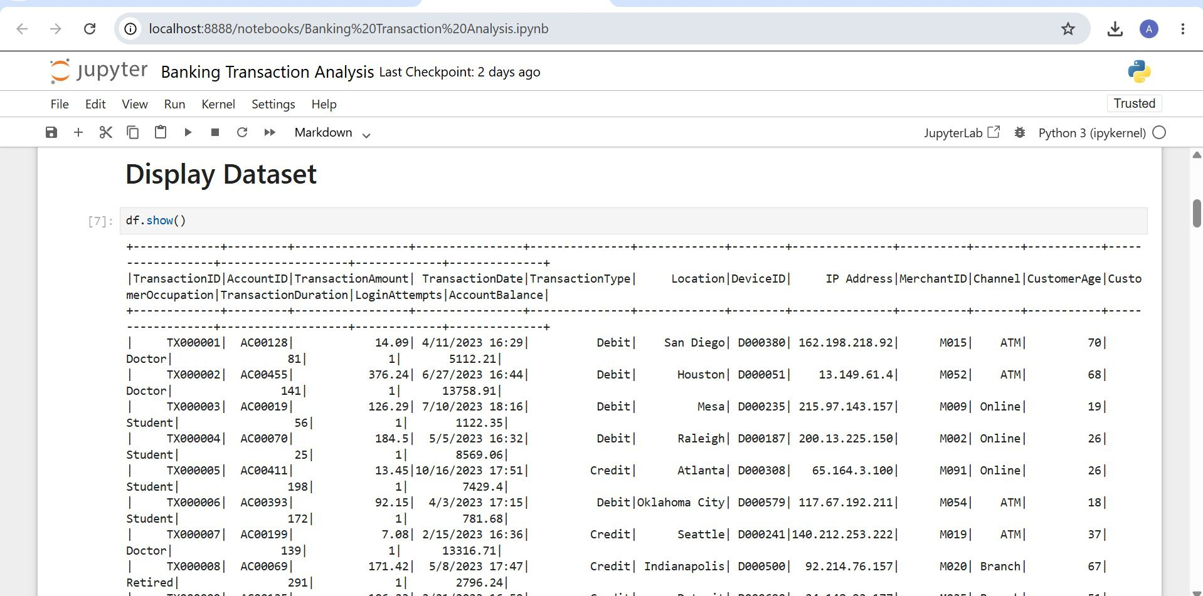
Figure 2: Display of the raw banking transaction dataset with all columns and sample records

4. Dataset Structure (Schema)
The printSchema() method reveals the data types and nullability of each column in the DataFrame. The schema shows that TransactionAmount and AccountBalance are stored as double (floating-point) values, while TransactionID, AccountID, and other identifier fields are strings. CustomerAge, TransactionDuration, and LoginAttempts are integers. All fields are nullable, which is typical for real-world data that may have missing values.

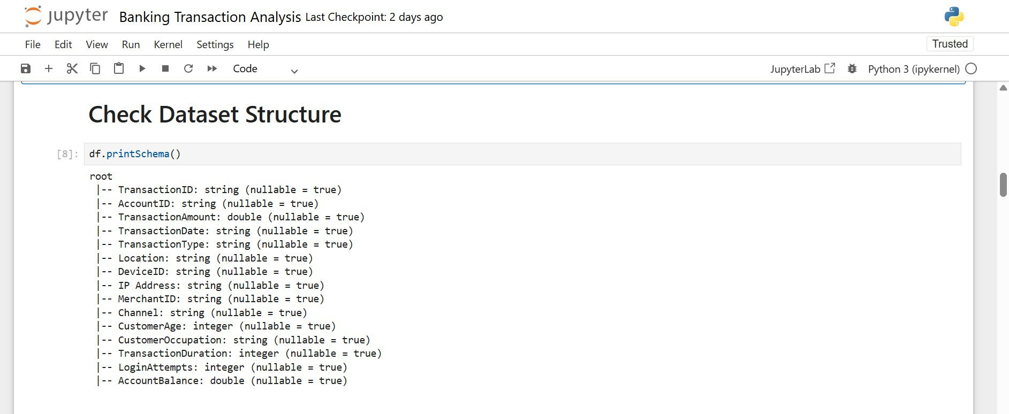
Figure 3: Dataset schema showing column names, data types, and nullability constraints

5. Data Cleaning
Data cleaning is a critical preprocessing step to ensure analysis accuracy. The dataset initially contains 50,000 transaction records as confirmed by df.count(). Two key cleaning operations are performed:

Remove Null Values: df.dropna() eliminates any rows containing missing or null values to prevent errors in aggregations and filters.

Remove Duplicate Records: df.dropDuplicates() removes any repeated transaction entries that could skew the analysis results.

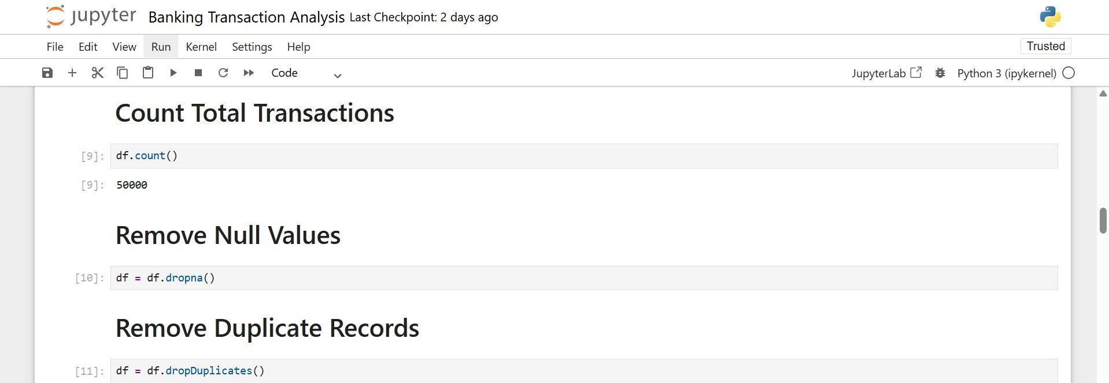
Figure 4: Data cleaning steps — counting total transactions (50,000), removing nulls and duplicate records

6. Highest Transactions
The top 10 highest-value transactions are identified by ordering the DataFrame in descending order of TransactionAmount using orderBy(col('TransactionAmount').desc()). The results reveal that the single highest transaction reached $2,060.59 (TX039963, Account AC00423, Portland, Debit via ATM). Notably, account AC00423 appears multiple times in the top results, suggesting repeated high-value debit activity from a Portland ATM, which could be a flag for further investigation.

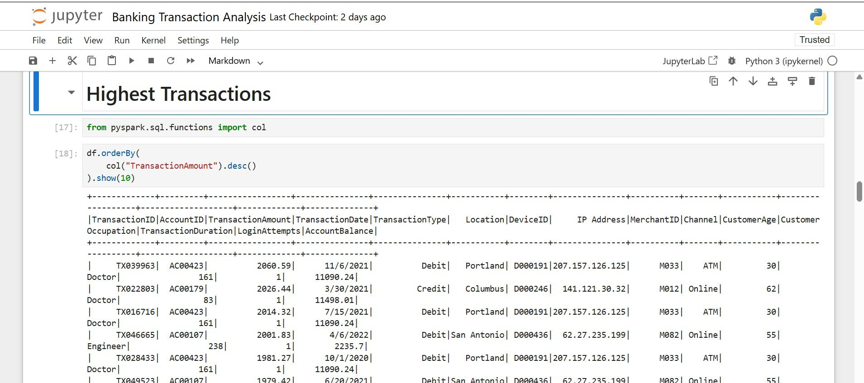
Figure 5: Top 10 highest banking transactions sorted by transaction amount in descending order

7. Average Transaction Amount
The average transaction amount across all 50,000 records is calculated using the avg() aggregate function from pyspark.sql.functions. The result shows an average transaction value of approximately $297.87. This metric serves as a useful baseline for identifying outliers and understanding typical customer spending behavior across the entire dataset.

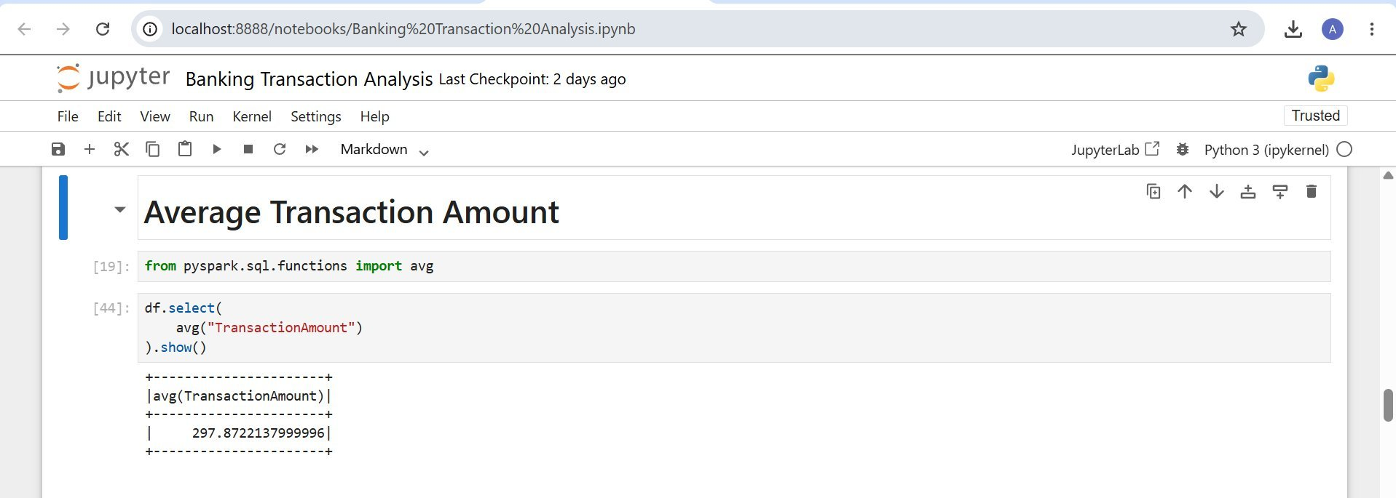
Figure 6: Average transaction amount across all records — approximately $297.87

8. Suspicious Transactions List
A fraud detection filter is applied using a threshold of $2,000. All transactions where the TransactionAmount exceeds this threshold are flagged as suspicious and stored in a separate DataFrame (fraud_df). The output shows high-value transactions such as TX022803 ($2,026.44 Credit from Columbus), TX016716 ($2,014.32 Debit from Portland), TX039963 ($2,060.59 Debit from Portland), and TX046665 ($2,001.83 Debit from San Antonio). These transactions warrant closer scrutiny for potential fraudulent activity.

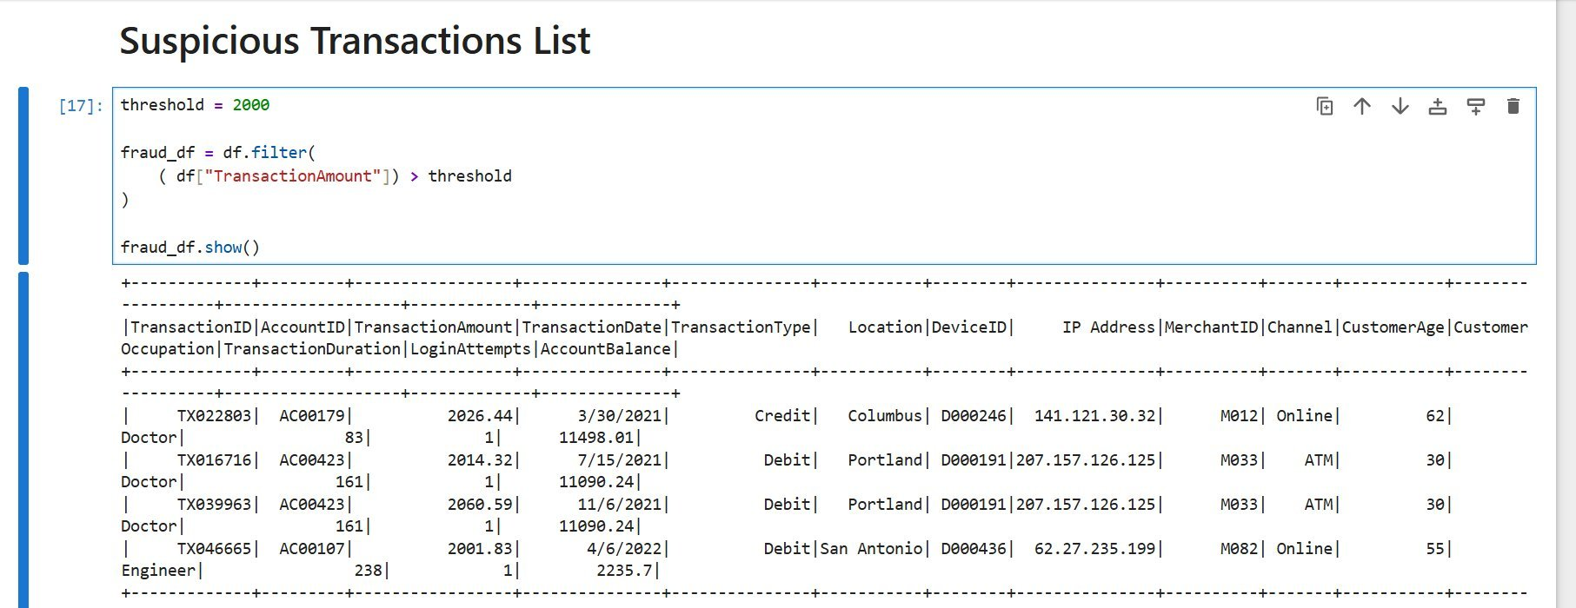
Figure 7: Suspicious transactions list — all transactions exceeding the $2,000 threshold

9. Most Active Customers
Customer activity is measured by the total number of transactions per account using groupBy('AccountID').count(). The results are sorted in descending order to reveal the top 10 most active customers. Account AC00363 leads with 249 transactions, followed by AC00202 (241), AC00460 (238), AC00362 (233), and AC00480 (230). This analysis helps identify power users and potential cases of unusually high transaction frequency that might indicate automated or fraudulent behavior.

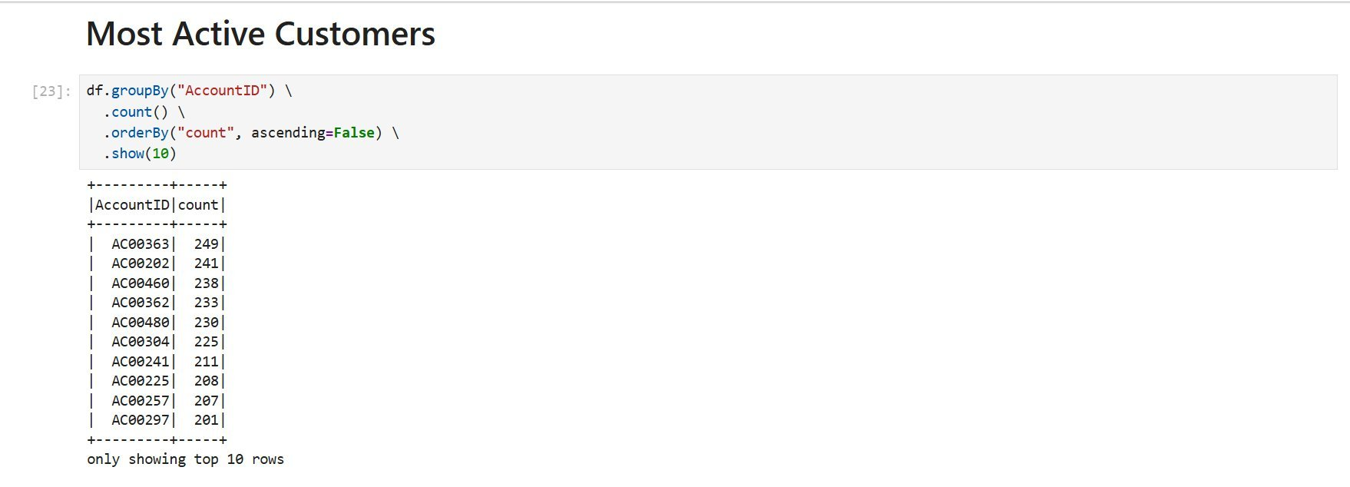
Figure 8: Top 10 most active customers ranked by total transaction count

10. Total Balance per Account
The total transaction amount per account is aggregated using groupBy('AccountID').agg(sum('TransactionAmount').alias('TotalBalance')). This gives a cumulative view of how much money has flowed through each account. Account AC00039 shows the highest total balance of approximately $42,029, while AC00002 records $44,530.62, and AC00069 reaches $40,212.60. This data is used downstream to generate the Top Accounts by Total Balance visualization.

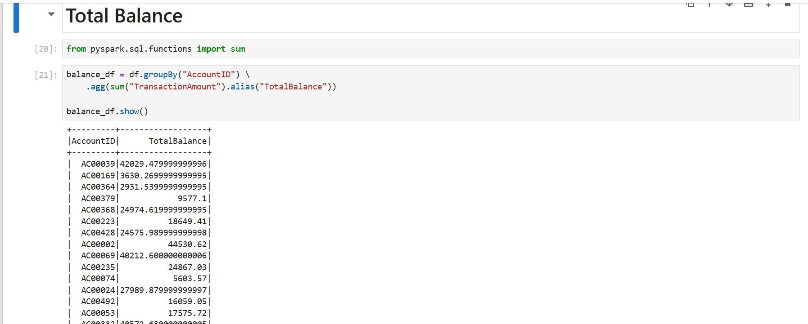
Figure 9: Total transaction balance aggregated per account using PySpark sum aggregation

11. Transaction Type Distribution (Chart)
A bar chart visualizes the distribution between Credit and Debit transactions. The chart clearly shows a dominant Debit count of approximately 39,000 transactions compared to Credit transactions at around 11,000. This significant imbalance — roughly a 3.5:1 ratio of Debit to Credit — indicates that customers predominantly withdraw or spend money rather than deposit it, which is a key behavioral insight for the bank's financial planning and risk assessment.

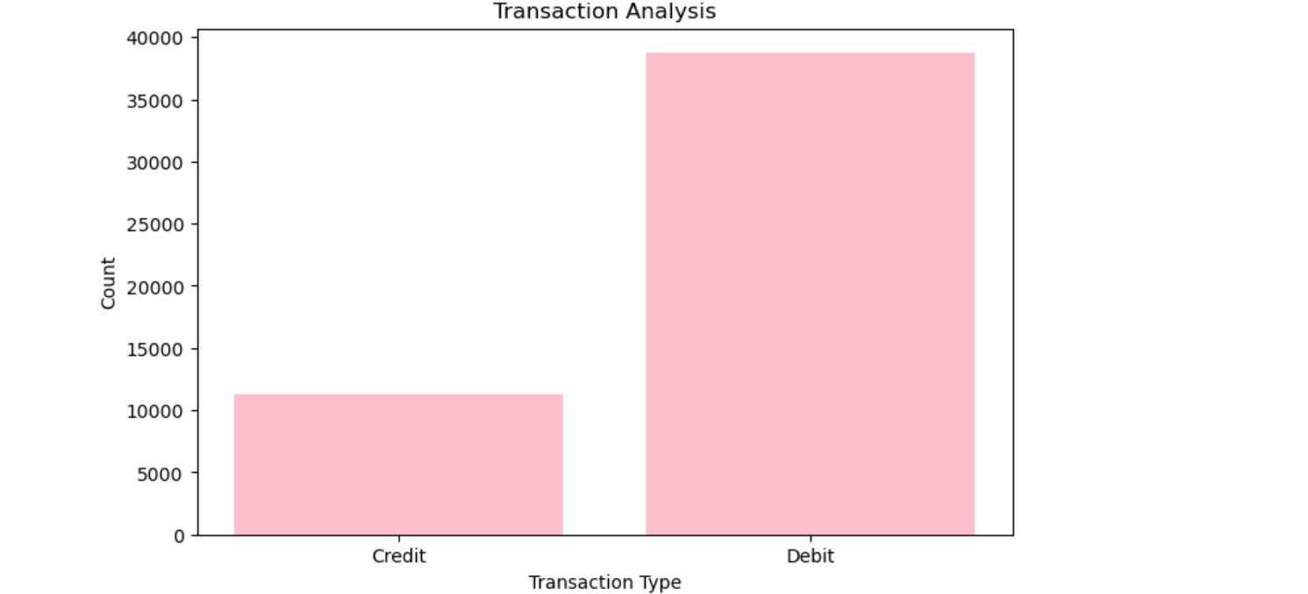
Figure 10: Bar chart showing transaction type distribution — Debit (~39,000) vs Credit (~11,000)

12. Top Accounts by Total Balance (Chart)
The final visualization presents a purple bar chart of the Top 10 Accounts by Total Balance. Account AC00460 holds the highest cumulative total of approximately $110,000, closely followed by AC00363 at around $103,000. The remaining top accounts (AC00337, AC00095, AC00021, AC00020, AC00136, AC00358, AC00202, AC00439) all range between $74,000 and $85,000. This chart provides a quick comparative view of high-value accounts and is vital for targeted financial services and wealth management strategies.

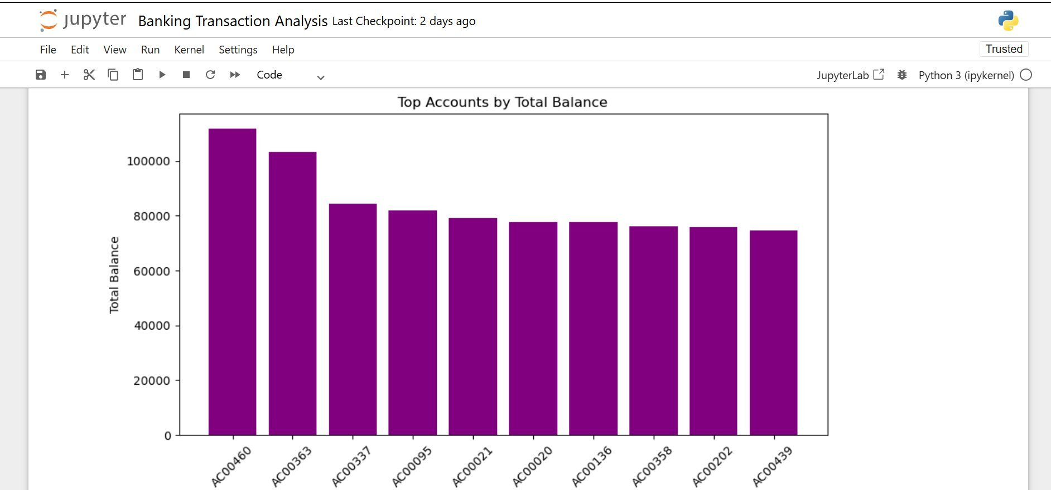
Figure 11: Bar chart of top 10 accounts by total accumulated transaction balance

13. Conclusion
This Banking Transaction Analysis project successfully demonstrates the power of PySpark for processing and analyzing large-scale financial datasets. By working with 50,000 transactions, the project achieved the following key outcomes:

- Efficient data ingestion and schema validation using PySpark DataFrames.
- Data quality improvement through null removal and duplicate elimination.
- Identification of high-value and suspicious transactions exceeding $2,000.
- Discovery of the most active customer accounts for targeted monitoring.
- Computation of average transaction amount (~$297.87) as a behavioral baseline.
- Visualization of transaction type distribution and top accounts by total balance.

The project establishes a strong foundation for building more advanced fraud detection systems, customer segmentation models, and real-time transaction monitoring pipelines using Apache Spark's distributed computing capabilities.

